Data Sheet
Product Information
Product Name | : | Recombinant Human Insulin-Like Growth Factor-1 (rhIGF-1)
Synonyms | : | IGF-1; IGF1; IGF-I; IGF1A; IGFI; Mechano growth factor; MGF; Somatomedin A; Somatomedin C
Description | : | IGF-1 is a hormone similar in molecular structure to insulin. It plays an important role in childhood growth and continues to have anabolic effects in adults. IGF-1 is a primary mediator of the effects of growth hormone (GH). Growth hormone stimulates the liver to produce IGF-1. IGF-1 then stimulates systemic body growth, and has growth-promoting effects on almost every cell in the body, especially skeletal muscle, cartilage, bone, liver, kidney, nerves, skin, hematopoietic cell, and lungs. IGF-1 can also regulate cell growth and development, especially in nerve cells, as well as cellular DNA synthesis. (Ref. From Wikipedia)
NCBI Accession No. | : | NM_001111285.1
Amino acid sequence | : | MGPETLCGAELVDALQFVCGDRGFYFNKPTGYGSSSRRAPQTGIVDECCFRSCDLRRLEMYCAPLKPAKSA
Molecular Mass | : | 7.76 kDa (71 aa)
Protein Tags | : | No tagging
Source | : | E. coli.
Cat. No. | : | JW-H018-0500, JW-H018-1000
Storage | : | Should be at ≤ -70 ℃ as undiluted aliquots of handy size. Avoid repeated freezing and thawing.
Cross Reactivity | : | Gerbil, Rat, Mouse, Human, Bacteria, Monkey, Mouse + Virus

Quality Control
Test items |  |  | Specifications
Appearance |  | : |  | Clear, colorless liquid
Purity |  | : |  | Greater than 95 % by SDS-PAGE
Specificity |  | : |  | Using Western blot, detection | 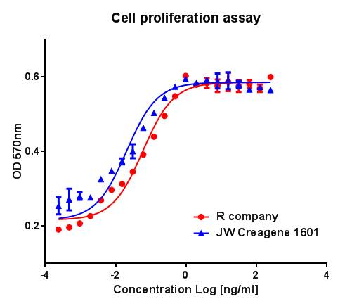
Concentration |  | : |  | 0.5 mg/㎖, Bradford method
Biological Activity |  | : |  | Determined by proliferation of MCF7 indicator cells.  The ED50 is < 0.3 ng/ml, corresponding to a specific activity of > 3.3 × 10⁶ EU/mg
Endotoxin |  | : |  | Less than 0.1 EU/㎍ as determined by the LAL method
Formulation |  | : |  | PBS (pH7.4) without preservative or carrier proteins.
Stability |  | : |  | Stable for up to 12 months at -70 ℃. Stable for a month at 4 ℃.
Sterility |  | : |  | Sterilized through a 0.2 ㎛ membrane filter and packaged aseptically. Culture for 2 weeks, no growth

